CONCERNED BLACK MEN OF
CALVERT COUNTY, INC.

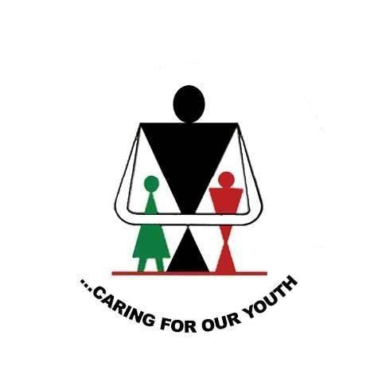

2016
Scholarship Application

SCHOLARSHIP AWARD

$1,000 Awarded Annually

MISSION STATEMENT:

To provide a holistic approach to services which support and strengthen the African-American family, and which specifically targets African-American youth. To establish a concerned male presence within the community with respect to positive role models and exposure to social, cultural, educational, spiritual, business and community linkages.

PURPOSE:

To provide scholarship assistance to eligible African American Calvert County high school graduates to participate in post-secondary education.

Eligibility Requirements

- Applicant must be an African American Student and a member in good standing of the current graduating class of Calvert, Huntingtown, Northern, or Patuxent High Schools;
- Student must have maintained a 2.0 or better grade point average over the last two (2) years of high school (official transcript must be included);
- Recipients of the award must be accepted by an accredited two (2) or four (4) year college and must use the award toward tuition and room/board;
- The scholarship award is for one (1) year only and will not be renewable. However, if the student maintains a “B” average during the freshman year (transcript must be provided by June 30 of the following year), a monetary donation will be awarded during the sophomore year;
- Applicant must submit “Letter(s) of Acceptance” from the institution(s) where admission is sought;
- Scholarship will be paid directly to college or university.

Criteria for Selection

The Selection Committee will consider the following criteria:

- Financial/economic need;
- Character and conduct;
- Participation in school and community activities;
- Attributes of good citizenship;
- Academic achievements;
- Goals and objectives of the student;
- Responsibility;
- Ability to work with others;
- Evidence of part-time employment.

Letters of Recommendations
Three (3) letters of recommendation are required with each application, two (2) from a school official, counselor or teacher and one (1) from a member of the community who knows the applicant outside of school.

Selection and Presentation of Award

Selection of the awardees will be made by the Washington, D.C. Chapter of the Concerned Black Men. An appearance before the Selection Committee may be required. Contenders will be notified of date, time and location.
The recipient of the scholarship award will be honored as part of the graduation exercise.

Obligations of Awardees

Scholarship Awardees should be prepared to provide a short bio for possible publication in the Souvenir Booklet.
Awardees and their parent(s) or guardian(s) are expected to be guests of the Concerned Black Men of Calvert County at its 18thAnnual Scholarship Banquet on May 13, 2016 at the Chesapeake Beach Spa and Resort Hotel in Chesapeake Beach, Maryland. Scholarship recipients will present a short review of their year of study and future plans.

Procedures to Follow

- Applicants will obtain the Scholarship Application from their Guidance Office or from The Concerned Black Men of Calvert County’s Website.
- The application must be completed and posted-dated by Friday, April 22nd, 2016;
- Notice of the availability of the Concerned Black Men of Calvert County Scholarship will be made known to students and the public by announcement in county newspapers and by Calvert, Huntingtown, Northern, and Patuxent High Schools during May 2016.
- Incomplete Applications will not be considered.

Disbursement of Funds

- Funds will be disbursed on or about August 15, 2016.
- Funds will be forwarded directly to the Awardees verified Institute of higher Education.
- Awardees are required to verify their school of choice by providing the following information to the Concerned Black Men of Calvert County, Inc. via phone, Email, or USPS:
  - Official mailing address of the Institution the awardees will be attending
  - The awardees “Student Identification” number issued by the institution the student will be attending.
  - Valid contact information for the awardees i.e. mailing address, Email, and phone number.
- No funds will be disbursed until the awardees meet the requirements stated above.

If awardees do not meet requirements stated in paragraph VII(C) by September 30, 2016 funds will revert back to the General Scholarship Fund to be awarded to future awardees.

